**III. The Third case: φd(σ) ≠ 0 and I(σ) is asymmetric**

 (1)

At T =1μm,

 (2)

 (3)

1. **b0 = 35, b1 = -10**μm **and φd(σ) = -4π(35-10σ)σ;**

**(1.a) Effect of φd(σ)**

 (4)

Table 1. The relevant parameters of *F(σ)* and *SC(z).*

|  |  |  |  |  |
| --- | --- | --- | --- | --- |
| σA | zo | λA | b0 | b1 |
| 1.5510μm-1 | 10μm | 0.6447μm | 35 | -10 |

Table 2. Simulation results shown in Figs.4 (c) and (d).

|  |  |  |  |  |  |
| --- | --- | --- | --- | --- | --- |
| za | zp | za-zo | zp-zo | P | zp-za |
| 15.8174μm | 15.9786μm | 5.8174μm | 5.9786μm | 0.3433μm | 0.1612μm |

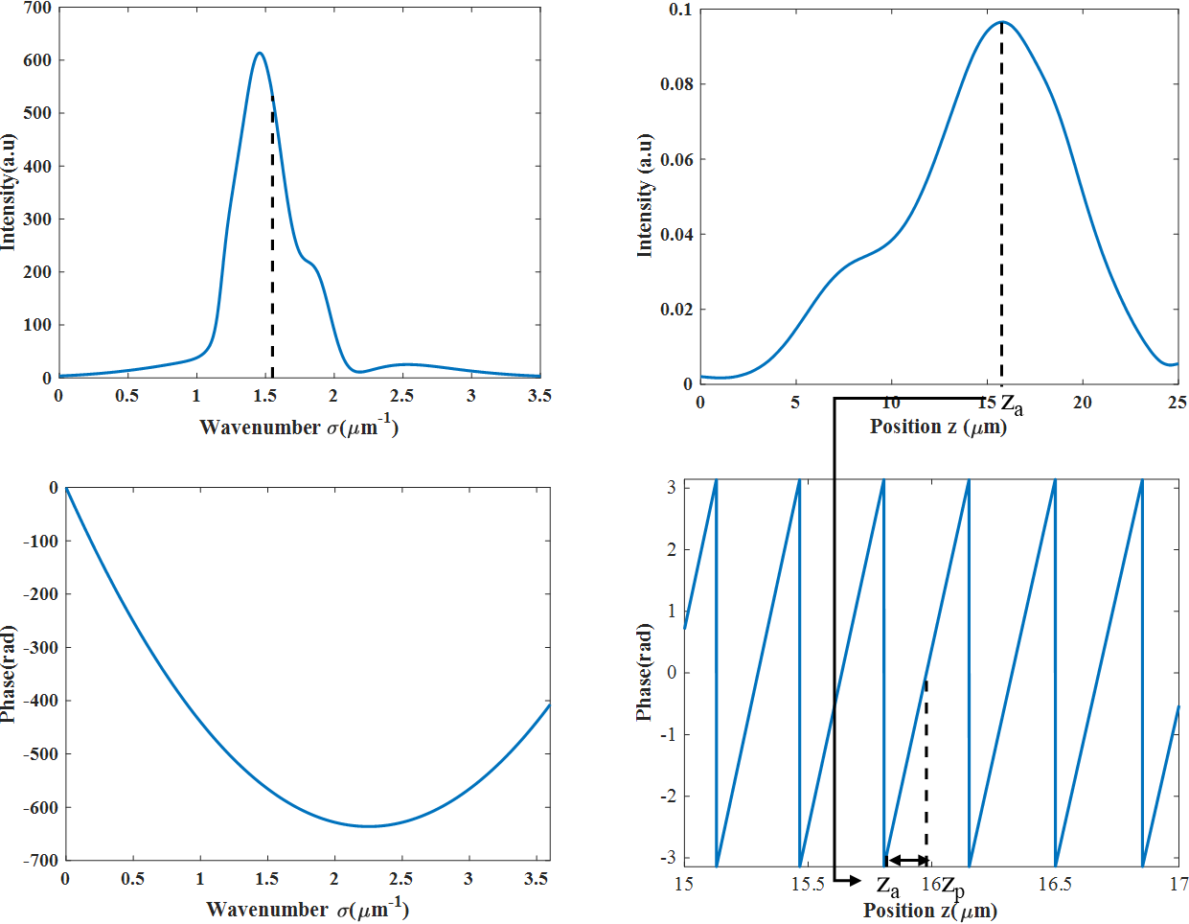

(d)

(b)

(c)

(a)

Fig. 1 IFT (Inverse Fourier transform) of *F(σ)*. (a) The intensity of *F(σ)*. (b) The phase of *F(σ)*.(c) The intensity of *SC(z)*. (d)The phase of *SC(z).* (e) The unwrap phase of *SC(z)。*

**Discussion1: How does the dispersion phase *ϕd*(*σ*) influence za?**

The linear term b­­­­0σ­­ of the phase function φd(σ) will produce a linear change in the position of za and zp, but the quadratic term will produce a nonlinear change in za and zp.

**(1.b) Elimination of effect of φd(σ) by using** **a least square line for phase distribution φ(σ) of F(σ).**

**Discussion2: Why the phase distribution φd(σ) can be eliminated by a least squares line?**

 (5)

 (6)

 (7)

a1=48.6184 rad∙μm 　a0=­-316.1931=2π×## -2.0338 rad∙μm ??

(8)

 (9)

zaT- zaS =0.0025 μm zpT- zpS =0.0010μm

Table 3. The relevant parameters of *F(σ)* and *SC(z).*

|  |  |  |  |  |
| --- | --- | --- | --- | --- |
| σA | zO | λA | a1 | a0 |
| 1.5510μm-1 | 10μm | 0.6447μm | 48.6184 rad∙μm | -316.1931 rad∙μm |

Table 4. Simulation results shown in Figs.4 (c) and (d).

|  |  |  |  |  |  |
| --- | --- | --- | --- | --- | --- |
| za | zp | za-zo | zp-zo | P | P-λA/2 |
| 6.1266μm | 6.2325μm | -3.8734μm | -3.7700μm | 0.333μm | 0.0106μm |

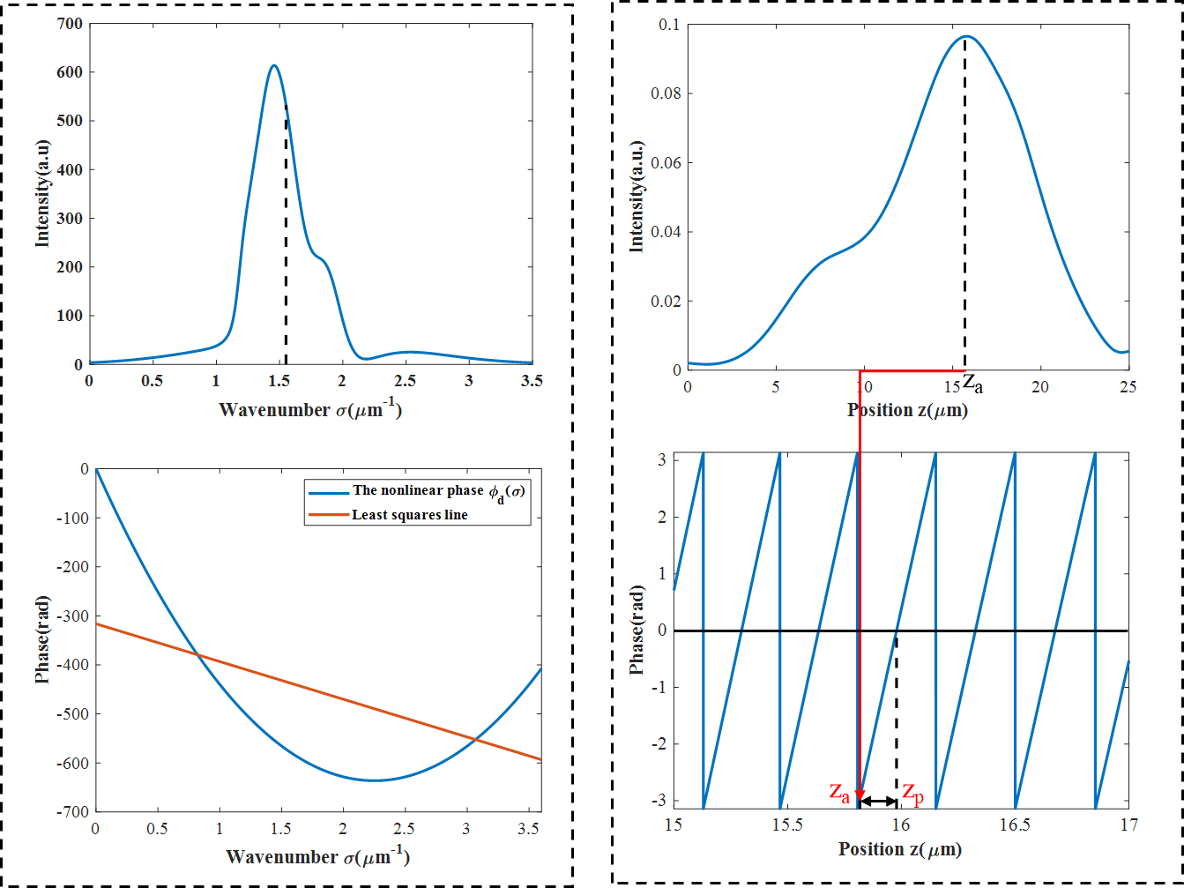

（d）

（b）

（c）

（a）

The nonlinear component of unwrap phase



（f）

（e）

Fig. 2 IFT (Inverse Fourier transform) of *F(σ)*. (a) The intensity of *F(σ)*. (b) The phase of *F(σ)* afterthe least squares method.(c) The intensity of *SC(z)*. (d)The phase of *SC(z).* (e) The unwrap phase of *SC(z).* (f) The nonlinear component of unwrap phase (Fig.2(e) - least square line of Fig.2(e))

1. **Different materials with different φd(σ).**

The above settings regarding the refractive index are arbitrary. In order to examine the effect of the dispersion phase φd(σ) and eliminate the effect of the dispersion phase, the different values of φd (σ) were used in the simulation when the noise φn did not exist.  
By querying the refractive index equations of different materials and substituting them into the above simulation, the following results can be obtained. The refractive index equations of different materials are shown in Table 5.

Table 5 The refractive index equations of different materials.

|  |  |  |
| --- | --- | --- |
| Materials | wavelength range | refractive index equations |
| N-BK7 | 350nm - 2.0 μm |  |
| N-F2 | 420nm - 2.0 μm |  |
| N-SF11 | 420nm - 2.3 μm |  |

In this simulation, Amplitude I(σ) has values in the region of σ from 0.25 μm-1 to 3.5 μm-1, as shown in Fig.3(a). The phase distribution calculated using the refractive index of N-BK7 glass is shown in the Fig.3(b). The ϕd(σ) is produced by an cand thickness T, ϕd(σ) is given by

 (10)

In this formula, the refractive index n(σ) can be obtained according to Table 5. Assume that the value of za and zp calculated theoretically is zaT and zpT, and the value obtained by simulation is zaS and zpS.

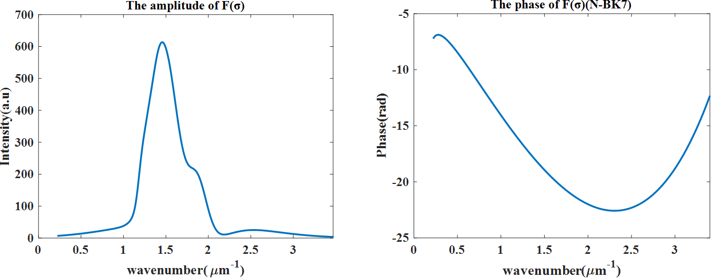

Fig. 3 (a) The intensity of *F(σ)*. (b) The phase of *F(σ)*(N-BK7).

Table 6 The relevant parameters of F(σ) .

|  |  |  |
| --- | --- | --- |
| σA | zO | λA |
| 1.5496μm-1 | 10μm | 0.6453μm |

Table 7 Simulation results at the different φd(σ) without noise.（The unit is μm）

|  |  |  |  |  |  |  |  |  |
| --- | --- | --- | --- | --- | --- | --- | --- | --- |
| materials | T  (μm) | a1  (μm) | a0  (μm) | zaT  (μm) | zpT  (μm) | zaS  (μm) | zpS (μm) | |
| N-BK7 | 17.5 | 122.5606 | 1.3183 | 0.2469 | 0.1792 | 0.2476 | | 0.2097 |
| N-F2 | 8 | 72.8850 | -0.2258 | 4.2000 | 4.2116 | 4.2007 | | 4.1635 |
| N-SF11 | 8 | 100.5450 | -0.8192 | 1.9989 | 2.0410 | 1.9994 | | 2.0006 |

|  |  |  |  |  |
| --- | --- | --- | --- | --- |
| materials | N-BK7 | | N-F2 | N-SF11 |
| P - λA/2 | 0.0673μm | 0.0679μm | | 0.0673μm |
| zaS - zaT | 0.0007μm | 0.0007μm | | 0.0005μm |
| zpS - zpT | 0.0305μm | -0.0481μm | | -0.0343μm |

Results are shown in Table 7, the differences between the theoretical values of za and the actual values are around 0.0007μm in the simulation which using different materials with different φd(σ), but the differences between the theoretical values of zp and the actual values are relatively large. Further inspection is required here, I guess it may be related to the value of period P and wavelength λA.

supplementary data：  
Compared with before, I have mainly modified the following points:

(1) In the wave number domain, the amplitude range changes from 0-3.5 to 0-3.25, so the sampling interval in the wave number domain changes from the previous 0.0038 to 0.00325.

(2) Different phase functions are selected.

(3) When calculating the zpS, the interpolation method is used.

The calculated results are shown in Table 9 and Table 9.

Table 8 The relevant parameters of F(σ) .

|  |  |  |
| --- | --- | --- |
| σA | zO | λA |
| 1.5394μm-1 | 10μm | 0.6496μm |

Table 9 Simulation results at the different φd(σ) without noise. Basic unit:μm

|  |  |  |  |  |  |  |
| --- | --- | --- | --- | --- | --- | --- |
| φ(σ) | a1 | a0 | zaT | zpT | zaS | zpS |
| -4π(45-10σ)σ | -31.8148 | -0.6613 | 12.5317 | 12.5659 | 12.5325 | 12.5666 |
| -4π(70-10σ)σ | -345.974 | -0.6613 | 37.5317 | 37.5659 | 37.5325 | 37.5666 |
| -4π(70-20σ)σ | 62.0342 | -1.3226 | 5.0635 | 5.1318 | 5.0643 | 5.1327 |
| -4π(20-35σ)σ | 1302.4 | 0.8270 | -93.6389 | -93.6817 | -93.6382 | -93.6811 |
| -4π(30-45σ)σ | 1584.7 | 0.1657 | -116.1072 | -116.1157 | -116.1064 | -116.1151 |
| -4π(30-45σ+10σ2)σ | 392.0627 | -0.8168 | -21.1994 | -21.1571 | -21.1989 | -21.1565 |
| -4π(20-35σ+10σ2)σ | 109.7182 | -0.1555 | 1.2689 | 1.2769 | 1.2692 | 1.2775 |
| -4π(5-20σ+15σ2)σ | -910.1219 | 0.3452 | 82.4252 | 82.4074 | 82.4261 | 82.4080 |

|  |  |  |  |  |
| --- | --- | --- | --- | --- |
| φ(σ) | P - λA/2 | | zaS - zaT | zpS - zpT |
| -4π(45-10σ)σ | 0.0064 | 7.1364×10-4 | | 6.3594×10-4 |
| -4π(70-10σ)σ | 0.0064 | 7.1364×10-4 | | 6.3594×10-4 |
| -4π(70-20σ)σ | 0.0069 | 8.2632×10-4 | | 8.7206×10-4 |
| -4π(20-35σ)σ | 0.0057 | 6.9486×10-4 | | 5.3338×10-4 |
| -4π(30-45σ)σ | 0.0059 | 8.0754×10-4 | | 6.0016×10-4 |
| -4π(30-45σ+10σ2)σ | 0.0062 | 4.4329×10-4 | | 6.6612×10-4 |
| -4π(20-35σ+10σ2)σ | 0.0063 | 3.3061×10-4 | | 6.0165×10-4 |
| -4π(5-20σ+15σ2)σ | 0.0057 | 8.8091×10-4 | | 5.9558×10-4 |